Circuit Analysis Lab 10
Proteus Circuits
Submitted By:
Shumaim Jameel (2025-CE-116)

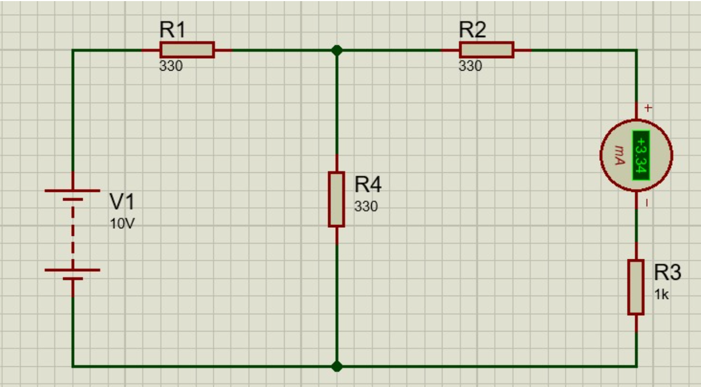

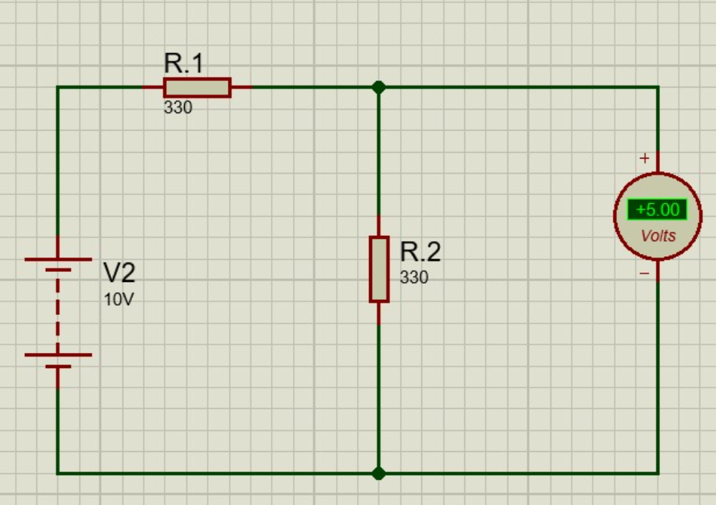

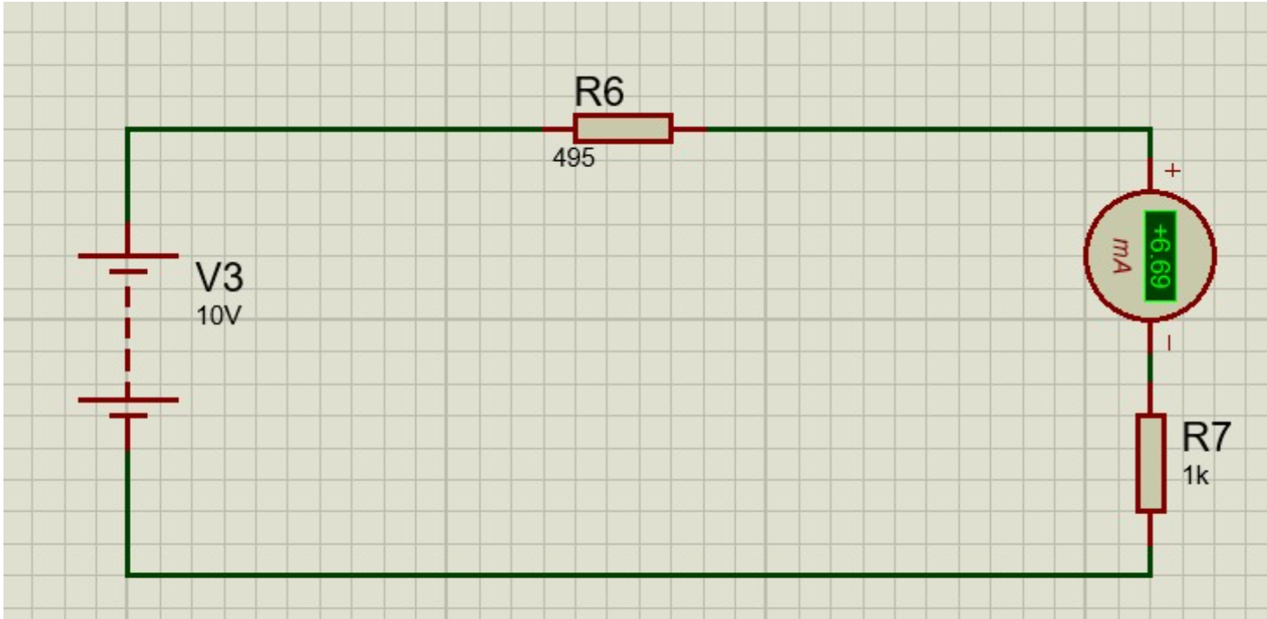

Thevenin Practical values:

 | E(V) | Vth(V) | Rth(ohms) | $I_{L}$ (mA)
 |  |  |  | Circuit-1 |  | Equivalent Circuit
Values | 10V | 10V | 495 | 3.34 | 6.69

